**Instructions for Authors**

**«Pharmacy & Pharmacology»**

Composed considering "Uniform Requirements for Manuscripts Submitted to Biomedical Journals", elaborated by International Committee of Editors of Medical Journals.

Timeliness, material novelty and its value in theoretical and/or applied aspects are the general criteria for the publication of articles in "Pharmacy and Pharmacology" journal. Editorial board organizes peer-reviewing of manuscripts.

“Pharmacy&Pharmacology” Journal is listed in the Russian Citation System (RCS), open repositories of scientific information: Ulrich’s Periodical Directory, eLibrary.ru, Biefeld Academic Search Engine (BASE), Open Archives Initiative, CrossRef, Socionetscientifif informational space, Directory of Open Access Scholarly Resources (ROAD), Cyberleninka Scientific electronic library, Russian State Library, Research Bible, Google Scholar, Russian Scientific Medical Journals (RNMJ.RU), All-Russian Institute of Scientific and Technical Information of Russian Academy of Sciences, Academic Keys,Directory of Open Access Journals (DOAJ). Editorial board provides DOI-digital identifier.

“Pharmacy & Pharmacology” Journal publishes leading articles, original studies, reviews, lectures, informational materials, peer-reviews. There is a place for discussions, publications on the history of pharmacy, brief reports, and anniversaries. All materials are peer-reviewed and discussed by the editorial board.

Articles are published in the following sections:

* reviews, lectures
* pharmacognosy, botany
* pharmaceuticaltechnologyandbiotechnology
* pharmaceuticalandtoxicologicalchemistry
* pharmacologyandclinicalpharmacology
* informationaltechnologiesinpharmacy
* organizationandeconomyofpharmacy
* economy and management of medicine
* pharmaceutical education
* brief reports
* discussions, peer-reviews, anniversaries, schools of thought, history of pharmacy and pharmacology

**Editorial board asks the authors to follow guidelines below while preparing the manuscripts for the journal**

**Manuscripts, formed without considering these guidelines, will not be considered by the board**

**GUIDELINES FOR MANUSCRIPTS SUBMISSION**

Manuscript subject to submission in “Pharmacy & Pharmacology” Journal requires that: 1) the information described was not published previously; 2) it is not under consideration in another publishing agency; 3) its publication was approved by all authors and organizations, where the study was conducted 4) in case of manuscript submission, the article will not be published anywhere else in the same form in English, or any other langue, including electronic form.

The articles are sent to the editorial board by mail: pharmjournal@mail.ru,   
journal@pharmpharm.ru, in *.doc or *.docx formats.

Electronic version must include: file with a text of an article, tables and figures.

If there are several authors, correspondence author should be indicated, his contacts: address, telephone/fax number, and additional details (all authors’ occupation, scientific degree, work place, area of expertise, e-mail, telephone, fax).

A manuscript must have an expert report, and covering letter (covering letter formed is attached). Covering letter is signed by all authors or establishment director (authenticated with a seal).

An article should be provided with an ORCID account (register of unique identifier of scientists, and a way to connect researching activity with these identifiers).

All articles sent for “Pharmacy & Pharmacology” submission are under anonymous (blind) peer-reviewing (manuscripts authors do not know peer-reviewers and receive a letter with corrections).

After the peer-review procedure and article submission, the authors’ names are to be changed (addition, removal, rearrangement). When sending the final version of the article to editorial board, make sure that authors’ list is whole and formed considering the guidelines.

**ATTENTION**: Authors are fully responsible for the authenticity and originality of the information represented in manuscripts. All manuscripts are to be checked for borrowings in “Antiplagiat” system. Authenticity of manuscripts must be at least 80%, otherwise a manuscript will be declined with no right to be published. If intellectual property rights violation is detected, retraction of the articles published will be carried out in accordance with COPE rules.

**ARTICLE PREPARATION**

“Pharmacy & Pharmacology” Journal publishes articles in Russian and English languages with an abstract.

The entire article (text, tables, notes, titles, foreign language insets, references, inscriptions under the figures etc) is typed on the computer in Times New Roman, 14 pt., 1.5 spacing, and margins: 20 mm from above and below, 30 mm from the left, 20 mm from the right. All pages should be consequently numbered.

Total volume of the original article should not exceed 15 pages (A4 sheet), short report volume is 4 pages. The volume and layout of other works (review, lecture etc) should be coordinated with editorial board in advance.

A manuscript must follow this plan:

1. UDC index
2. Article title
3. Initial letters and authors’ surnames
4. The whole names with addresses of the establishments, to which authors belong. If authors work in different establishments, the links of each author with his organization is manifested with upper case numbers.
5. An abstract with 200-250 words of typed text with article’s content. It is not recommended to use formulas in graphical format. Abstract is an autonomous part of a manuscript, therefore all the acronyms must be deciphered herein.

An abstract must contain:

* Initial data
* Objective
* Research problem
* Description of what an article is devoted to
* Description of methods/ materials involved.
* Results
* Scientific contribution
* Conclusions
* Area of application
* Limits/directions of the future studies

1. Keywords (6 at most), no dot at the end
2. Article must follow the structure:

* INTRODUCTION section. Brief summary, which reflects the problem by the time of articlewriting and a purpose of the study. To show the timeliness and novelty of the study, to make a hypothesis, and to find ways of its proving;
* METHODS section. The description of the methods of a study. There must be rather detailed description of the work of its reconstruction. Methods, published before, should be attached with references: author only describes the changes referred to a theme;
* RESULTSsection. Кроме описания экспериментов в нем должны приводиться данные об источниках использованных реагентов и сорбентов или достаточно подробные их характеристики, применяемых приборах, ссылки на типовые методики и т.п.;
* DISCUSSION section(the section may be joined with RESULTS section).There’s a grounded interpretation of the results, demonstration of their significance, for reader not only to estimate methodological advantages and disadvantages of the study but to reconstruct it as well;
* CONCLUSION section.There are principal conclusions of the paper, recommendations for the further studies;
* GRATUTUDE section. If necessary. Authors should point out the data additional funds, including numbers of grants. It should include persons, organizations, funds etc., which implemented some assistance to the authors in their study, work, etc. (for example financial, linguistic assistance, correction, writing assistance etc);
* References.

1. Conflict of objectives. Providing scrupulosity and open-mindness of the materials published, it is necessary to exclude the influence of any conflict of objectives. The editorial board and peer-reviewers do not have right to:

* be bound with financial responsibilities;
* be bound with commercial organizations, interested in publication of the article;
* itself from taking a decision about publication, which can be influenced by personal motives, believes or narrow mindness;
* to inform about a potential conflict of objectives;
* to inform author about the process of an independent peer-review (for example informing about which part is under external peer-review);
* to consider manuscripts as confidential documents and require the same from editors and peer-reviewers;
* to strive for a strict division of functions of employees who participate in editorial and business activity of the journal.

Patientssurnames, clinical histories’ numbers are not allowed to be used while describing clinical studies, including figures. Describing the experiments on animals you should point if the use of laboratory animals corresponded to the GLP requirements and principal rules of European Council Conventions “On the protection of animals, used in trials and other scientific purposes”, Directions of European Parliament and Council of European Union “About the Protection of Animals Used in Scientific Purposes”, as well as national laws and regulations of the establishment.

Editorial board is able to correct English translation. Authors are recommended to provide in English a list of specific terms, reactions, reagents, biological objects names, trivial names of compounds, drugs, used in the article for the best possible interpretation of the text’s massage. After the completion of all the stages of the peer-reviewing and applying of the article, a full author translation of the final version of the article into English must be done, or ordered in the editorial board of the journal, using the services of the professional translator. If translation quality is satisfying it will be published (after editing).

**English versionof the article mustcoincide with a structure and meaning of a Russian article and must be grammatically correct in English.**

The results and illustrations, provided as figures, tables, and graphs are put into the text right after the first mention. There should be an indication in the text, for example: (table 1) or (figure 1).

Every table should be numerated (with Arabic) and named (without acronyms) above the table. All graphs in tables should be titled; all acronyms should be deciphered in the table notes. Table title, its contents and notes should be provided in Russia and English languages. Table titles font is Times New Roman, bold italic, 12, 1 interval.

Tables with more than one page should be sent in a separate file considering all the requirements mentioned above.

Every figure should be numerated (with Arabic) and titled (without acronyms) under the figure. If the figure contains some explanation, it should be as minimum as possible; all acronyms should be deciphered in the figure notes. The figure title and its notes should be provided in Russian and English languages with the following format: Times New Roman, bold italic, 12, 1 interval.

Every figure used in the article should be additionally attached to the document in *.JPG, *.TIFF or *.PNG with at least 600 px/inch definition. *.TIFF is a preferable format for color images, and *.PNG is preferable for bit image. Do not use another images format (for example *.GIF, *.PICT, *.WPG) or images with less definition.

Graphs and diagrams, presented in an article are formed as well as figures, however they should be additionally attached to the electronic version in *.XLS, *.XLSX, *.PPT or *.PPTX. The information in a graph or diagram should be formed so every element would be clearly seen and distinguished from another. Entire descriptive text should be minimal. Deciphering of the descriptive text should be attached below. Name and descriptions should be given in **Russian and English** languages, using Times New Roman, bold italic, 12 size, 1 interval.

Tableformexample:

Таблица 3 – Антимикробная активностьнастойки (1:5)(экстрагент – спиртэтиловый 70%)

***Table 3–Antimicrobialactivityoftincture(1:5)(extragent–70%ethanol)***

|  |  |  |  |  |  |  |  |  |  |  |  |  |
| --- | --- | --- | --- | --- | --- | --- | --- | --- | --- | --- | --- | --- |
| Штамм микро-организма /Microbialstrain | Порядковыйномерразведения / Serial number of dilution | | | | | | | | | | | |
| 1 | 2 | 3 | 4 | 5 | 6 | 7 | 8 | 9 | 10 | 11 | 12 |
| *Pseudomonas aeruginosa* | Ростанет / No growth | Ростанет / No growth | Ростанет / No growth | Ростанет / No growth | Рост / Growth | Рост / Growth | Рост / Growth | Рост / Growth | Рост / Growth | Рост / Growth | Рост / Growth | Рост / Growth |
| *Staphylococcus aureus* | Ростанет/ No growth | Ростанет/ No growth | Ростанет/ No growth | Ростанет / No growth | Рост / Growth | Рост / Growth | Рост / Growth | Рост / Growth | Рост / Growth | Рост / Growth | Рост / Growth | Рост / Growth |
| *Escherichia coli* | Ростанет / No growth | Ростанет / No growth | Ростанет / No growth | Рост / Growth | Рост / Growth | Рост / Growth | Рост / Growth | Рост / Growth | Рост / Growth | Рост / Growth | Рост / Growth | Рост / Growth |
| *Bacillus cereus* | Ростанет / No growth | Ростанет / No growth | Ростанет / No growth | Ростанет / No growth | Ростанет / No growth | Ростанет / No growth | Ростанет / No growth | Ростанет / No growth | Ростанет / No growth | Рост / Growth | Рост / Growth | Рост / Growth |
| *Candida albicans* | Ростанет/ No growth | Ростанет/ No growth | Ростанет/ No growth | Рост / Growth | Рост / Growth | Рост / Growth | Рост / Growth | Рост / Growth | Рост / Growth | Рост / Growth | Рост / Growth | Рост / Growth |

Figure example:

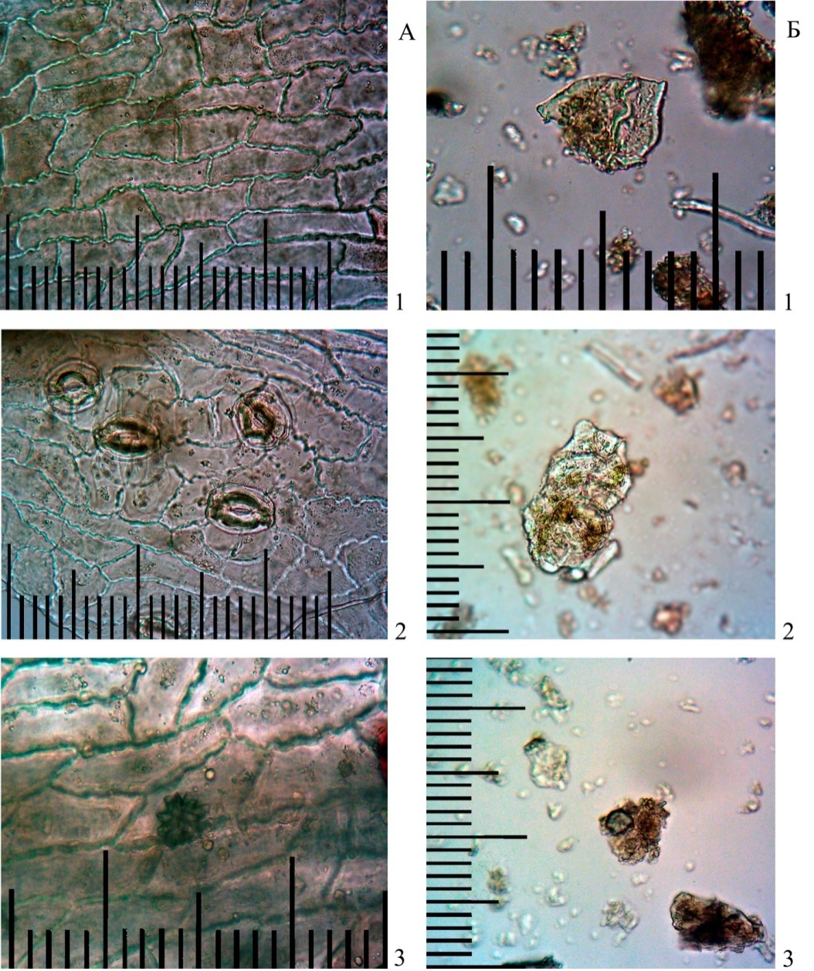

***Рисунок 1 – Диагностические элементы в микропрепаратах с поверхности листа (А) и из таблеток (Б):***

***1 – эпидермис, 2 – устьица, 3 – друзы***

***Figure 1 – Diagnostic elements in leaves (A) and in the tablets (Б):***

***1 – epidermis, 2 – stomata, 3 – calcium oxalate druse crystals***

**REFERENCES**

Literature quoted should contain at least 10 resources. At least 50% of the resources from the references list must be timely (published recent 5 years) including journals, which are listed in ***Web of Science, Scopus, Science Index****.* There can be references to earlier literature only if necessary. References do not include educational aids, normative and archive materials, collected statistics, newspapers articles without an author, monographs, author abstracts, and dissertations.

Resources with **DOI** are desirable to be in references**.**

**References form:**

Numbers of references are written in square brackets and are at one line with a text. References numbers (in square brackets) must be in order of their mention in the text.

**An author is fully responsible for an accuracy of references including English translation.**

**1. Russian version - according to GOST P 7.0.5–2008.**

References in Russian version are given in original language.

All references must follow the same template: only with a dot, without a dash between description parts. Symbols like № and & are not used; a number is pointed with N without a dot; description of a bigger document of reference is separated with a double slash. There is no dot before double slash //. Spaces before and after // are obligatory.

**2. English (REFERENCES)**

References in English serve the detection of citation of authors and journals in the first place. Correct description of the resources used in the article is a guarantee for a publication quoted to be considered while estimating the scientific activity of its authors, and therefore the organization, region, country. Scientific level, credibility, efficiency of its editorial board activity etc are determined by the journal’s citation.

Resources and papers names are given in full form, without acronyms. All authors are indicated.

**It is not allowed** to use signs like //, -, and № in English references.

***Examples of References lists:***

**Description of a journal article:**

**InRussian:**

Евсеева С.Б., Сысуев Б.Б. Использование природных минеральных солей в современных косметических рецептурах: ассортимент продукции, характеристика сырья и особенности технологии // Фармация и фармакология. 2016. №2 (15). С.4-25. DOI:http://dx.doi.org/ 10.19163/2307-9266-2016-4-2(15)-4-25.

**In English**

Chashchin V.P., GudkovА.B., Popova О.N., Odland J.Ö., KovshovА.А. Description of Main Health Deterioration Risk Factors for Population Living on Territories of Active Natural Management in the Arctic.Human Ecology.2014, no. 1, рр. 3-12. (in Russian)

**Description of an electronic journal article:**

**InRussian**

Конторович А. Э., Коржубаев А. Г., Эдер Л. В. Прогноз глобального энергообеспечения: методология, количественные оценки, практические выводы // Минеральные ресурсы России. Экономика и управление: сетевой журн. 2006. N5. URL: <http://www.vipstd.ru/gim/content/view/90/278/> (дата обращения: 22.05.2012).

**In English**

Kontorovich A.E., Korzhubaev A.G., Eder L.V. Forecast of global energy supply: Techniques, quantitative assessments, and practical conclusions.2006, no. 5. (In Russian) Available at: http://www.vipstd.ru/gim/ content/view/90/278/). (Accessed: 22.05.2012)

**Description of conferences materials:**

**InRussian**

Воронков А.В., Терехов А.Ю., Дьякова И.Н., Ляхова Н.С. Влияние препарата «Нурофен, суппозитории ректальные для детей, 60 мг» на содержание кальция и хлора в сыворотке крови неполовозрелых крыс // Разработка, исследование и маркетинг новой фармацевтической продукции: сб. науч. тр./ Пятигорский медико-фармацевтический институт. Пятигорск,2014.Вып. 69. С.267-270.

**Books description:**

**InRussian**

ФурстГ.Г. Методы анатомо-гистохимического исследования растительных тканей. М.:Наука,2008. 250 с.

**In English**

Swan M. Practical English Usage. 3 ed. Oxford: Oxford Univ. Press,2005.

**GOST Description:**

**In Russian**

ГОСТ 8.586.5–2005. Государственная система обеспечения единства измерений. Измерение расхода и количества жидкостей и газов с помощью стандартных сужающих устройств. М. :Стандартинформ, 2007.143 c.

**In English**

GOST 8.586.5–2005.Method of measurement.Measurement of flow rate and volume of liquids and gases by means of orifice devices. Moscow, Standartinform Publ., 2007. 10 p. (In Russian)

**It is recommended to use original article reference on the dissertation paper instead of the references on the dissertations and author abstracts of dissertations, because dissertation are considered to be manuscripts and are not considered a published source.**

Article form example:

УДК 613.495:616.5-083.4(048.8)

**ОТРИЦАТЕЛЬНЫЕ ПОСЛЕДСТВИЯ   
НЕКОТОРЫХ КОСМЕТИЧЕСКИХ ПРОЦЕДУР:  
ВОЗМОЖНОСТИ ИХ ПРЕДОТВРАЩЕНИЯ, ЛЕКАРСТВЕННЫЕ  
И ЛЕЧЕБНО-ПРОФИЛАКТИЧЕСКИЕ СРЕДСТВА (ОБЗОР)**

***1А.В. Майорова, 2К.Н. Корянова, 2Э.Ф. Степанова***

*1ФГАОУ ВПО Российский университет дружбы народов, г. Москва, Россия*

*2Пятигорский медико-фармацевтический институт –  
филиал ГБОУ ВПО ВолгГМУ Минздрава России, г. Пятигорск, Россия*

**THE NEGATIVE EFFECTS OF SOME COSMETIC PROCEDURES: PROTECTION POSSIBILITIES, MEDICAL AND PREVENTIVE AGENTS (REVIEW)**

***1A.V. Majorova, 2K.N. Koryanova, 2E.F. Stepanova***

*1People’s Friendship University of Russia, Moscow, Russia*

*2Pyatigorsk Medical and Pharmaceutical Institute – branch of Volgograd State  
Medical University of the Ministry of Health of Russia, Pyatigorsk, Russia*

*E-mail: medesta@yandex.ru*